K-means Clustering:

K | plot
2  Inertia = 43.54690551467469 | 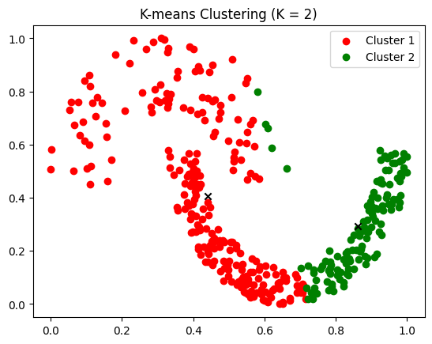
4  Inertia = 13.641112605334651 | 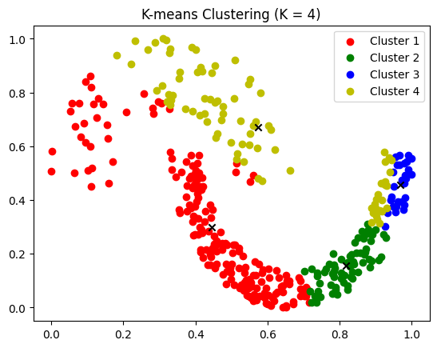
6  Inertia = 8.646621058785321 | 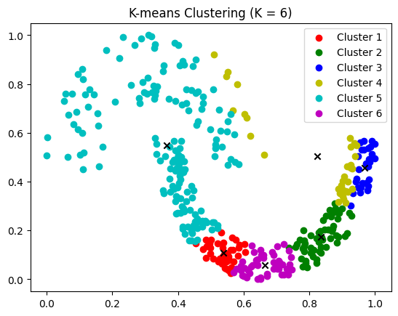
7  Inertia = 8.596898337160958 | 